H.T No
Regulations:
A22

Sreenidhi Institute of Science and Technology
(An Autonomous Institution)
Code No:9EC01 Date: 09-July-2025 (FN)

B.Tech I-Year II- Semester External Examination, July-2025 (Regular and Supplementary)
DATA STRUCTURES (Common to All)

Time: 3 Hours Max.Marks:60

Note: a) No additional answer sheets will be provided.
b) All sub-parts of a question must be answered at one place only, otherwise it will not be valued.
c) Missing data can be assumed suitably.
Bloom's Cognitive Levels of Learning (BCLL)

Remember | L1 | Apply | L3 | Evaluate | L5
Understand | L2 | Analyze | L4 | Create | L6

Part - A Max.Marks: 6x2=12

Answer all QUESTIONS, EACH QUESTION CARRIES 2 MARKS.

 |  | BCLL | CO(s) | Marks
1 | Define enumerated data type. Give an example. | L1 | CO1 | [2M]
2 | Convert the expression (a+b–d*a/c) to postfix expression. | L3 | CO2 | [2M]
3 | Define Circular linked list. | L1 | CO2 | [2M]
4 | Write a function for post-order tree traversal. | L1 | CO2 | [2M]
5 | Define quadratic probing. | L1 | CO3 | [2M]
6 | Compare linear and Binary search techniques. | L1 | CO4 | [2M]

Part – B Max.Marks: 6x8=48
ANSWER ALL QUESTIONS. EACH QUESTION CARRIES 8 MARKS.

 |  | BCLL | CO(s) | Marks
7 | Discuss nested structures with example. | L3 | CO1 | [8M]
 | OR
8 | Discuss the data type Union with suitable example. Write any two differences between Structure and Union. | L4 | CO1 | [8M]
9 | Write the function to perform push(), pop() and display() operations on a stack. | L4 | CO1 | [8M]
 | OR
10 | Write the functions to enqueue, dequeue and display elements of queue. | L4 | CO1 | [8M]
11 | Write an algorithm to perform postfix evaluation of a given expression. | L4 | CO2 | [8M]
 | OR
12 | Write functions to perform all three insertions and all three deletions operations on single linked list. | L3 | CO2 | [8M]
13 | 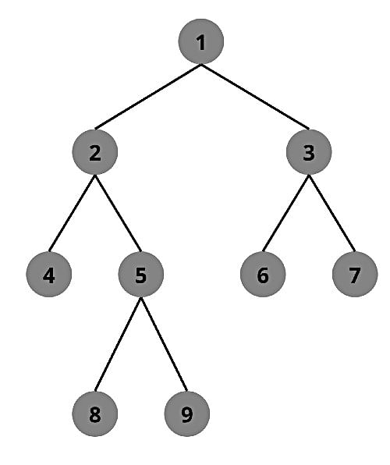  Write the inorder, preorder and postorder traversals of above tree. | L2 | CO2 | [8M]
 | OR
14 | Construct AVL Tree with the following elements. 7, 8, 9, 4, 3, 6, 2, 5, 1. | L2 | CO2 | [8M]
15 | Define Heap. And also explain the process of arranging elements in an ascending order using Heap Sort with suitable example. | L4 | CO4 | [8M]
 | OR
16 | Write the differences between Linear probing and Quadratic probing. | L3 | CO3 | [8M]
17 | Write the function to arrange the elements in ascending order using Merge Sort. | L4 | CO4 | [8M]
 | OR
18 | Arrange the following array of elements in descending order using Quick Sort. 12, 23, 9, 6, 10, 15, 18 and 8. | L2 | CO4 | [8M]

-- 00 -- 00 –

